IEC 61850 Breaker Failure Demo – IED Configuration Guidelines

Timeline
- July 8 - ICD files due from each participating device are due
- July 11 – Begin system engineering
  - July 18 - Preliminary SCD/CID files for import into IED Config Tools
  - July 25 - Second round of ICD files due
  - Aug 8 - Final SCD/CID files available for testing
- Aug 21 - Setup and test at Cigre (Sunday, Aug 24, 9AM)

ICD File
Pre-defined datasets and pre-configured GOOSE Control Blocks (GCBs) and Report Control Blocks (RCBs) to be included in the ICD files. See details in later sections for Addressing, DataSets, and GOOSE publisher/subscriber info.
Datasets must include data listed in sections below, but can include additional data chosen by vendors. Otherwise, vendors should specify what the SCT should put into the dataset (specific FCDA statements).
If possible, the Inputs/ExtRef section(s) should be set up within the ICD file to assist the system configurator.
The System Configuration Tool will need to support Edition 1 and 2 SCL Files.

Breaker Failure Demo Overview
The Breaker Failure Demo will include GOOSE, Sampled Values, and Client/Server reporting.

Process Simulation
The power flow for one of the feeders will be simulated including CT, VT, and Circuit Breaker. This simulation will feed the analog inputs for the merging unit which will send a sampled values stream using 9-2 LE profile to the SV IED. In the simulation, the bus will be 220 kV @ 50 Hz and each of the simulated loads will be 200MW (524A).

Fault Injection
There will be two options for initiating a trip in the breaker failure demo:
- Process Simulation Fault – in this case, a process simulation will be performed with a simulated fault (PTOC) that will be detected by an IED (A-N fault with VAN=97.5 kV and IA=1700 A, with unfaulted phases remaining the same as prefault).
- Panel Trip – in this case, a trip will be initiated from the IED panel.

Breaker Simulation
IED will need to simulate breaker operation including failure condition. Vendors may also choose to bring a “physical” breaker. The concept is for booth visitors to have a visual indication of the breaker operation
In the case of the process simulation and SV IED, the breaker will be simulated by the process simulation or test set and the breaker failure logic will be in the SV IED. In the case of the other IEDs, the circuit breakers and breaker failure logic will be simulated by the IEDs. Each vendor can choose how to display breaker status, breaker failure, and GOOSE messaging on front panel.
The Doble test set will have scenarios to show both the breaker fail and the breaker successful open. During the first fault injection, the simulated Doble breaker will open successfully. During the second fault injection, the simulated Doble breaker will fail. After a reset, the Doble test set will start over.

RBRF Logic
RBRF logic will be demonstrated in the IEDs in either the Process Simulation or the Panel Trip scenarios. The SV IEDs will have an RBRF logical node which will monitor the XCBR which is in the process simulation. The SEL IED will monitor the RTDS breaker and the EFACEC IED will monitor the Doble breaker.

Sampled Values
The sampled values stream will use the 9-2 LE profile. Separate VLAN will be configured to keep Sampled Values only on ports that need to see SV messages.
The SV IEDs will be able to monitor either the SV stream from the Doble test set or the RTDS process simulation. The SV IEDs will manually switch between the two process simulations. When a fault is injected by one of the process simulations, then any of the SV IEDs that are monitoring the SV stream with that fault will indicate an overcurrent condition (PTOC.Str) and send a trip (PTRC.Op).

GOOSE
Several GOOSE messages will be used to start the demo sequence, indicate trip, breaker failure, and demo reset.

Client/Server
IEDs will use reports to send relevant data to Clients which will include MMXU, XCBR, RBRF, LGOS, and PTRC status. Optionally, include PTOC.

Option 1: Process Simulation Fault

Doble Only - Sequence for Breaker Success Scenario (Not done by RTDS)
The Doble Test Set will perform the following sequence to show the simulated breaker open successfully before performing the breaker failure sequence:
- Process Simulation or Test Set injects pre-fault conditions for a 220kV system at 200MW load at 50Hz (220 kV L-L, 127 kV L-N and load current 524 A at unity power factor) which is broadcast in sampled values stream. Client can read these values. Process Simulation and Test Set will send breaker status (closed) to SV IEDs (RTDS will send GGIO.Ind and Doble will send XCBR.Pos).
- Injection transitions to fault condition (this can be started by any of the IEDs/tools sending a GOOSE with GGIO.Ind). Process Simulation or Test Set receive GOOSE and then simulate A-N fault with VAN=97.5 kV and IA=1700 A, with unfaulted phases remaining the same as prefault.
- SV IED detects the fault and broadcasts GOOSE with PTOC.Str
- After a preset time delay (long enough to be observable, 5 seconds) SV IED operates and broadcasts GOOSE with PTOC. Op and PTRC.Op
- Process Simulation and Test Set receive PTRC.Op=True from SV IED and attempt to open breaker
- Simulated breaker opens (0.1 second CB opening delay to simulate reality) and breaker status (open) is sent to SV IEDs (RTDS will send GGIO.Ind and Doble will send XCBR.Pos). Process Simulation or Test Set will clear fault (zero current, normal voltage).
- SV IED detects that breaker opened (SEL monitors RTDS, EFACEC monitors Doble) using breaker status info (optionally can use current from sampled values) and resets RBRF logic, and does not send RBRF.Opex=true. Other IEDs do nothing.
- This “fault cleared” state will last for a duration of 5 seconds, after which simulation will automatically proceed to the next scenario (second fault condition and failure of breaker to open) which is shown in the section below.

Note: Doble Test Set will use a PC tool to subscribe to multiple GOOSE messages from IEDs and OR the inputs together for step 2

RTDS and Doble - Sequence for Breaker Failure Scenario
The sequence for the breaker failure scenario is shown below. This will be done by both the Doble Test Set and the RTDS process simulation:
- Process Simulation or Test Set injects pre-fault conditions for a 220kV system at 200MW load at 50Hz (220 kV L-L, 127 kV L-N and load current 524 A at unity power factor) which is broadcast in sampled values stream. Client can read these values. Process Simulation and Test Set will send breaker status (closed) to SV IEDs (RTDS will send GGIO.Ind and Doble will send XCBR.Pos).
- Injection transitions to fault condition (this can be started by any of the IEDs/tools sending a GOOSE with GGIO.Ind). Process Simulation or Test Set receive GOOSE and then simulate A-N fault with VAN=97.5 kV and IA=1700 A, with unfaulted phases remaining the same as prefault.
- SV IED detects the fault and broadcasts GOOSE with PTOC.Str
- After a preset time delay (long enough to be observable, 5 seconds) SV IED operates and broadcasts GOOSE with PTOC. Op and PTRC.Op
- Process Simulation and Test Set receive PTRC.Op=True from SV IED and attempt to open breaker
- Simulated failure of breaker (does not open) and fault condition persists. Process Simulation and Test Set will continue to send breaker status (closed) to SV IEDs (RTDS will send GGIO.Ind and Doble will send XCBR.Pos).
- SV IED detects breaker failure (SEL monitors RTDS breaker, EFACEC monitors Doble breaker) after waiting 5 seconds for breaker status to change to open (optionally can monitor current from sampled values) and broadcasts GOOSE with RBRF.OpEx=true
- Other IEDs receive RBRF.OpEx and trip breaker (and optionally, broadcast GOOSE with RBRF.OpEx=true)
- Process Simulation or Test Set will clear fault (zero currents and also zero voltages since all breakers are connected to a single bus) after receiving GOOSE from IED with RBRF.OpEx=true. RTDS Process Simulation will clear fault by opening backup breaker. Doble Test Set will zero voltage and current.
- Demo is reset by any of the IEDs/Test Tools sending a GOOSE with CSWI.OpCls. IEDs should reset to initial conditions. Process Simulation or Test Set should reset simulation to pre-fault conditions (normal voltages and load current and closed breaker).
Note: Doble Test Set will use a PC tool to subscribe to multiple GOOSE messages from IEDs and OR the inputs together for step 2 and 10

SV IED Protection Function Settings
- Enable Phase PTOC
  - Pickup setting = 800 A
  - Time delay = 5 seconds
- Enable RBRF
  - Logic based on breaker position (option to use current from sampled values)
  - Time delay = 5 seconds

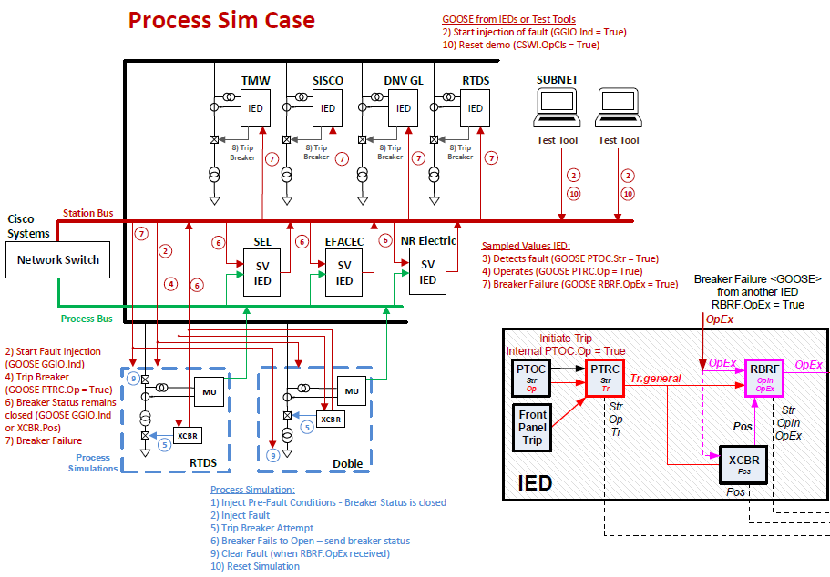

Option 2: Panel Trip

Sequence for Breaker Failure
Below is a diagram which shows the sequence of the panel trip demo:
- Initiate trip from front panel of IED
- IED sends GOOSE with PTRC.Op
- IED attempts to open breaker
- Simulated failure of breaker (does not open)
- IED detects failure and broadcasts GOOSE with RBRF.OpEx
- Other IEDs receive RBRF.OpEx and trip local breaker. Process Simulations will trip local breakers and set simulated current to zero.
- Demo is reset by any of the IEDs/Test Tools by sending a GOOSE with CSWI.OpCls. IEDs should reset to initial conditions. Process Simulation or Test Set should reset simulation to pre-fault conditions (normal voltages and load current and closed breaker).
There is also the option to show the successful breaker opening scenario in which the breaker opens and the RBRF logic is reset and the IED does not send RBRF.Opex=true to the other IEDs.
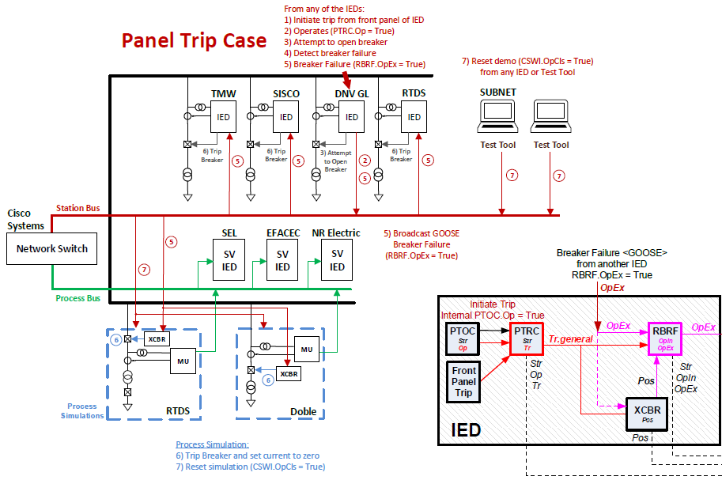

GOOSE Publishing/Subscribing

Table 1: Process Sim Case
Purpose | Publisher | Subscriber | Dataset must include
Start Fault Injection | Any IED or Test Tool | Process Sim/Test Set | GGIO.Ind1.stVal (RTDS)  GGIO.Ind2.stVal (Doble)
Start of Fault Detection | SV IEDs | Monitoring tools | PTOC1.Str.general (RTDS)  PTOC2.Str.general (Doble)
Trip | SV IEDs | All other IEDs | PTRC1.Op.general (RTDS)  PTRC2.Op.general (Doble)
Breaker Status | Process Sim/Test Set | SV IEDs | GGIO.Ind.stVal (RTDS)  XCBR.Pos.stVal (Doble)
Breaker Failure | SV IEDs | All other IEDs | RBRF.OpEx.general
Reset Demo | Any IED or Test Tool | All IEDs | CSWI.OpCls.general

Table 2: Panel Trip Case
Purpose | Publisher | Subscriber | Data
Trip | IED | All other IEDs | PTRC.Op.general
Breaker Failure | IED | All other IEDs | RBRF.OpEx.general
Reset Demo | Any IED or Test Tool | All IEDs | CSWI.OpCls.general

GOOSE Datasets
FCDA elements in GOOSE datasets must include the data attributes (i.e. daName must be specified) listed in Table 1 and Table 2 above for compatibility with all devices. Data objects can be added in addition to the data attributes if desired.

Start Fault Injection
Any IED or Test Tool can send this GOOSE to start the Process Sim demo sequence. GGIO.IndX=True is received by Process Sim/Test Set to inject fault into process sim. The X addressing is used to identify the target Process Sim/Test Set device (X=1 for RTDS, X=2 for Doble) to inject fault.
DataSet should include: GGIO.Ind1.stVal (RTDS), GGIO.Ind2.stVal (Doble)

Start of Fault Detection by SV IED
When the SV IED detects the fault in the SV stream, it will send PTOC.Str
DataSet must include: PTOC1.Str.general, PTOC2.Str.general

Trip
When the SV IED detects the fault in the SV stream, it will send PTRC.Op.general (PTRC1 for RTDS and PTRC2 for Doble)
DataSet must include: PTRC1.Op.general, PTRC2.Op.general

Breaker Status
Process Simulation or Test Set will send a GOOSE indicating the breaker position. The SV IEDs will monitor this to determine if the breaker was able to operate or if it failed.
DataSet must include: GGIO.Ind.general (RTDS) or XCBR.Pos.stVal (Doble)

Breaker Failure
When the breaker fails to open, the IED will send RBRF.OpEx.general
DataSet must include: RBRF.OpEx.general

Reset Demo
CSWI1.OpCls is used to reset the breaker failure scenario (first GOOSE message to set TRUE and a second GOOSE about 1 second later to set it FALSE). IEDs to subscribe to this GOOSE as input to XCBR.
Test set should reset simulation to pre-fault conditions (normal voltages and load current and closed breaker). IEDs should reset to initial conditions: XCBR(Pos=on), RBRF (Str=false, OpEx=false), PTOC (Str=false, Op=false), PTRC (Op=false), GGIO(Ind1=false, Ind2=false)
DataSet should include: CSWI.OpCls.general

GOOSE Subscription Notes
Vendors to specify (in writing) how to set up SCD file for subscriptions to external GOOSE to show the state of the Boolean(s).
If possible, the Inputs/ExtRef section(s) should be set up within the ICD file to assist the system configurator.

Client/Server
Below are Client/Server services that will be demonstrated:

Reports
The following Clients will subscribe to Report Control Blocks (RCB’s) from the IED’s. Specific RCB’s will be allocated to the different vendors so that there is always an available RCB for each Client.
Vendor | Client | Assigned RCB #
SISCO | AX-S4 61850 Client | 1
DNV GL | Client Simulator | 2
SUBNET | HMI – Client | 3
Triangle MicroWorks | Distributed Test Manager | 4
Doble | 61850TesT – client simulator | 5
RTDS | MMS Voyageur | 6
SEL | SEL 3355 | 7
Efacec | System Point | 8
At a minimum the RCB for each IED should include:
- RBRF (Str, OpEx, OpIn)
- PTOC (Str, Op)
- PTRC (Str, Tr, Op)
- XCBR (Pos)
- LGOS (if the IED supports this)
- MMXU (3ph currents and voltages)
Clients will show time delay between PTOC.Str and PTOC.Op because the SV IED will include a 5 second delay between these two objects.

Sampled Values Publishing Subscribing

Process Sim Case
Purpose | Publisher | Subscriber | Data
CT/VT data | Process Sim/Test Set | SV IEDs | 9-2 LE Profile
There will be two process sims running and each will publish sampled values.
There will be multiple SV IEDs that will be able to monitor either the SV stream from the Doble test set or the RTDS process simulation. The SV IEDs will manually switch between the sampled values stream from the two process simulations. When a fault is injected by one of the process simulations, then any of the SV IEDs that are monitoring the SV stream with that fault will indicate an overcurrent condition (PTOC.Str) and send a trip (PTRC.Op).

Addressing
Each vendor will have a range of addresses to use:

X = unique participation ID (from Table 3)
Y = ordinal number for each device assigned by each vendor (first in SCL is 0, next is 1, etc.)
Z = ordinal number for GoID and SvID and APPID usage assigned by each vendor

IP addresses: 172.16.X.Y (in decimal)
Netmask: 255.255.0.0
Gateway: 172.16.16.1 (if used)
GOOSE MAC addresses are 01-0C-CD-01-00-XZ where XZ in hex
SV MAC addresses are 01-0C-CD-04-00-XZ where XZ in hex
GOOSE APPID = 0x00XZ where XZ in hex
SV APPID = 0x40XZ where XZ in hex
GoID = Vendor_Device_XZ

VLAN ID = 1 for Client/Server
VLAN ID = 2 for Station Bus (GOOSE)
VLAN ID = 3 for Process Bus (SV)
VLAN Priority = 4 for GOOSE/SV

Table 3: Addressing by Vendor
Vendor | Vendor #  (X) | Device #  (Y) | GOOSE/SV #  (Z) | IED | Client | GOOSE Monitor
RTDS | 1 | 0-15 (0-F) | 0-15 (0-F) | IED Simulator | MMS Voyageur | GOOSE Simulator
Doble | 2 | 0-15 (0-F) | 0-15 (0-F) | F6150sv test set | 61850TesT sw | 61850TesT sw
Cisco | 3 | 0-15 (0-F) | 0-15 (0-F)
SEL | 4 | 0-15 (0-F) | 0-15 (0-F) | SEL-411L
SISCO | 5 | 0-15 (0-F) | 0-15 (0-F) | AX-S4 61850 IED Simulator | AX-S4 61850 Client | AX-S4 GOOSE
EFACEC | 6 | 0-15 (0-F) | 0-15 (0-F)
DNV GL | 7 | 0-15 (0-F) | 0-15 (0-F) | IED Simulator | Client Simulator | UniCA 61850 Analyzer
SUBNET | 8 | 0-15 (0-F) | 0-15 (0-F) |  | HMI - Client | GOOSE Monitor
Triangle MicroWorks | 9 | 0-15 (0-F) | 0-15 (0-F) | Anvil IED Simulator | Distributed Test Manager | Hammer
NR Electric | 10 (A) | 0-15 (0-F) | 0-15 (0-F) | PCS-902

