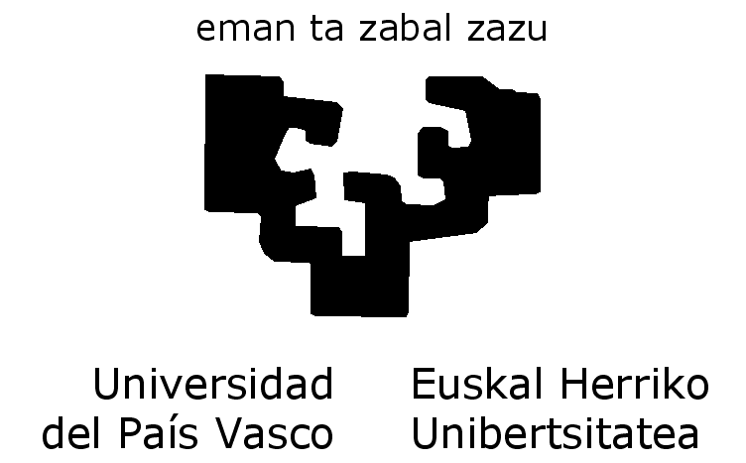

IEC 61850 AND IEC 62439 TECHNICAL INTEROPERABILITY TEST – BILBAO 2014

Author: | SoC-e
Revised: | SoC-e
Version: | 140707

Bilbao, July 1st 2014

REVISION HISTORY

Ver . | Date | Responsible | Comments
140609 | 2014/06/09 | AA | Initial version
140613 | 2014/06/13 | AA | Logistics and Hotel Info
140617 | 2014/06/17 | MI, AG | Test-Plan initial proposal
140625 | 2014/06/25 | MI, AG | Revised according to new topology proposal without RSTP
140701 | 2014/07/01 | MI | Added Flexibilis and Ingeteam to the pre-testing topologies
140707 | 2014/07/07 | AA | Schedule
140709 | 2014/07/09 | AG | Ping test added, minor corrections
Table 1 : Changes in the document

INDEX
REVISION HISTORY ii
INDEX iii
FIGURE INDEX 4
TABLE INDEX 5
1 INTRODUCTION 6
1.1 UCAIug Booth Topology 2014 7
1.2 Participants Role and Equipments 9
1.3 Test Premises Layout 9
2 TEST PLAN 10
2.1 CIGRE2014 IEC62439/IEC61850 Pre-Testing 10
2.1.1 Test 1A : Equipment physical interconnection 12
2.1.2 Test 1B: Network testing 12
2.1.3 Test 1D: Running IEC61850 demo application (Breaker Failure) 12
2.2 Optional Test 1: IEEE1588 with IEC62439 over CIGRE2014 Network Topology 13
2.2.1 Optional Test 1A. Basic Test 14
2.2.2 Optional Test 1B. Open and close HSR ring 14
2.2.3 Optional Test 1C. Network impairments. 15
2.3 Optional Test 2: 1GE HSR IEEE1588 P2P 17
2.3.1 Optional Test 2A. Basic Test 18
2.3.2 Optional Test 2B. Open and close RSTP and HSR rings 18
2.3.3 Optional Test 2C. Network impairments. 19
3 TEST SCHEDULE / TIMETABLE 21
4 LOGISTICS AND OTHER ADDITIONAL INFORMATION 23
4.1 INTEROPERABILITY PREMISES LOCATION 24
4.2 SHIPMENTS LOGISTICS 25
4.2.1 Shipment address 25
4.2.2 Dates for packages collect/delivery 25
4.3 HOTEL INFORMATION 27

FIGURE INDEX
Figure 1: Conceptual Topology 7
Figure 2: Network Topology 8
Figure 3: Pre-Testing. Topology I 10
Figure 4: Pre-Testing. Topology II 11
Figure 5: Pre-Testing. Topology III 13
Figure 6: Pre-Testing. Topology IV 17
Figure 7: Location of the Faculty of Engineering and the NH Hotel 24
Figure 8: Interop. premises location 25
Figure 9: NH Bilbao Hotel Location 28
Figure 10: Hesperia Hotel Location 29
Figure 11: Ercilla Hotel Location 30

TABLE INDEX
Table 1 : Changes in the document ii

INTRODUCTION

The aim of this document is defining the technical test that will be run in the IEC 61850 AND IEC 62439 TECHNICAL INTEROPERABILITY TEST in BILBAO.

Additionally, this document can be used as a unique guide for the attendees due it include all the additional information related to shipment logistics, hotels and timetables.

UCAIug Booth Topology 2014

Figure 1: Conceptual Topology

Figure 2: Network Topology

Participants Role and Equipments
TBD Mikel

Test Premises Layout

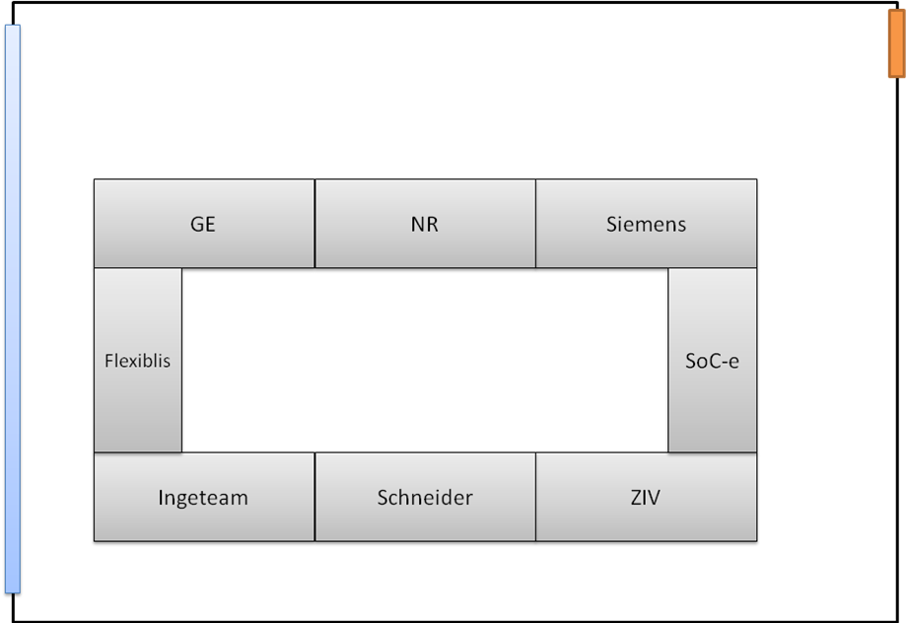

TEST PLAN

CIGRE2014 IEC62439/IEC61850 Pre-Testing
Figure 3: Pre-Testing. Topology I

Figure 4: Pre-Testing. Topology II

Test 1A : Equipment physical interconnection
Test set-up
Network topology is shown in Figure 3.
Redundancy in HSR ring is according to IEC 62439-3 Chap 5.

Test sequence
- Check link status and autonegotiation results in every device.
- Check Supervision frames received from every device.

Expected results
All devices are physically connected to their neighbours and send supervision frames.

Test 1B: Network testing
Test set-up
Network topology is shown in Figure 3.
Redundancy in HSR ring is according to IEC 62439-3 Chap 5.
A ping flood is executed between two pingable devices.

Test sequence
- Start ping flood between devices.
- Break HSR ring.
- Check ping req/res.
- Close HSR ring.
- Stop ping and check statistics.

Expected results
Every ping request is responded.

Test 1D: Running IEC61850 demo application (Breaker Failure)
TBD

Optional Test 1: IEEE1588 with IEC62439 over CIGRE2014 Network Topology
Figure 5: Pre-Testing. Topology III

Optional Test 1A. Basic Test
Test set-up
Network topology is shown in Figure 5. GrandMaster is connected to a single network and this through a Transparent Clock to the HSR ring.
Redundancy in HSR ring is according to IEC 62439-3 Chap 5. PTP configuration used is Utility Profile IEC 62439-3/CDV:2014 Annex B
- Layer 2 Ethernet
- Multicast
- P2P delay calculation mechanism
- 2-step
- PTP management and signaling disabled
- 1 announce/s, 1 sync/s, 1 pdelay_req/s

Test sequence
- Switch all slaves on.
- Check that all slaves are synchronized to the GM using a PPS signal.

Expected results
All slaves should be synchronized below 1us.

Optional Test 1B. Open and close HSR ring
Test set-up
Network topology is shown in Figure 5. GrandMaster is connected to RSTP network and this through a StateLess Transparent Clock to the HSR ring.
Redundancy in HSR ring is according to IEC 62439-3 Chap 5. PTP configuration used is Utility Profile IEC 62439-3/CDV:2014 Annex B
- Layer 2 Ethernet
- Multicast
- P2P delay calculation mechanism
- 2-step
- PTP management and signaling disabled
- 1 announce/s, 1 sync/s, 1 pdelay_req/s

Test sequence
- Switch all slaves on.
- Check that all slaves are synchronized to the GM using a PPS signal.
- Break HSR ring.
- Check synchronization.
- Close HSR ring.
- Check synchronization.

Expected results
All slaves should be synchronized below 1us in steps 2, 4 and 6.

Optional Test 1C. Network impairments.
Test set-up
Network topology is shown in Figure 5. GrandMaster is connected to RSTP network and this through a Transparent Clock to the HSR ring. Traffic generator is connected to the HSR ring through a RedBox.
Redundancy in HSR ring is according to IEC 62439-3 Chap 5. PTP configuration used is Utility Profile IEC 62439-3/CDV:2014 Annex B
- Layer 2 Ethernet
- Multicast
- P2P delay calculation mechanism
- 2-step
- PTP management and signaling disabled
- 1 announce/s, 1 sync/s, 1 pdelay_req/s

Traffic load description
- Multicast
- Packet length RFC 2544

Test sequence
- Switch all slaves on.
- Check that all slaves are synchronized to the GM using a PPS signal.
- Inject traffic by steps (10%, 20%, 40%, 60%, 80%, 90%).
- Check synchronization in each step.

Expected results
All slaves should be synchronized below 1us during all test duration.

Extra impairment tests
Using a net impairment equipment inserted in HSR ring, several impairments could be forced such as packet dropping, bit error, duplicated packets or packet delay variation. These tests can be determined in situ under the requirements of the attendees.

Optional Test 2: 1GE HSR IEEE1588 P2P
Figure 6: Pre-Testing. Topology IV

Optional Test 2A. Basic Test
Test set-up
Network topology is shown in Figure 6. GrandMaster is connected through a StateLess Transparent Clock to the HSR ring.
Redundancy in HSR ring is according to IEC 62439-3 Chap 5. PTP configuration used is Utility Profile IEC 62439-3/CDV:2014 Annex B
- Layer 2 Ethernet
- Multicast
- P2P delay calculation mechanism
- 2-step
- PTP management and signaling disabled
- 1 announce/s, 1 sync/s, 1 pdelay_req/s

Test sequence
- Switch all slaves on.
- Check that all slaves are synchronized to the GM using a PPS signal.

Expected results
All slaves should be synchronized below 1us.

Optional Test 2B. Open and close RSTP and HSR rings
Test set-up
Network topology is shown in Figure 6. GrandMaster is connected through a Transparent Clock to the HSR ring.
Redundancy in HSR ring is according to IEC 62439-3 Chap 5. PTP configuration used is Utility Profile IEC 62439-3/CDV:2014 Annex B
- Layer 2 Ethernet
- Multicast
- P2P delay calculation mechanism
- 2-step
- PTP management and signaling disabled
- 1 announce/s, 1 sync/s, 1 pdelay_req/s

Test sequence
- Switch all slaves on.
- Check that all slaves are synchronized to the GM using a PPS signal.
- Break HSR ring.
- Check synchronization.
- Close HSR ring.
- Check synchronization.

Expected results
All slaves should be synchronized below 1us in steps 2, 4, and 6.

Optional Test 2C. Network impairments.
Test set-up
Network topology is shown in Figure 6. GrandMaster is connected through a StateLess Transparent Clock to the HSR ring.
Redundancy in HSR ring is according to IEC 62439-3 Chap 5. PTP configuration used is Utility Profile IEC 62439-3/CDV:2014 Annex B
- Layer 2 Ethernet
- Multicast
- P2P delay calculation mechanism
- 2-step
- PTP management and signaling disabled
- 1 announce/s, 1 sync/s, 1 pdelay_req/s

Traffic description
- Multicast
- Packet length RFC 2544

Test sequence
- Switch all slaves on.
- Check that all slaves are synchronized to the GM using a PPS signal.
- Inject traffic by steps (10%, 20%, 40%, 60%, 80%, 90%).
- Check synchronization in each step.

Expected results
All slaves should be synchronized below 1us during all test duration.

Extra impairment tests
Using a net impairment equipment inserted in HSR ring, several impairments could be forced such as packet dropping, bit error, duplicated packets or packet delay variation. These tests can be determined in situ under the requirements of the attendees.

TEST SCHEDULE / TIMETABLE

Monday, 14th of July | Test | Comments
14-19h | None | Room open for equipments mounting
19h- | None | Room is locked
Tuesday, 15th of July | Test | Comments
8:30-9:30h | None | Room open for equipments mounting
9:30h-11:00h | Test 1A : Equipment physical interconnection
11:00-11:15h | None | Coffee Break
11:15-13:15h | Test 1B: Network testing
13:15-14:15 | Lunch | Sandwiches and refreshments available in the Interop. Location
14:15-17:00 | Test 1D: Running IEC61850 demo application
17:00- |  | Room is locked
Wednesday, 16th of July | Test | Comments
9:00-10:00h | Optional Test 1A. Basic Test
10:00-11:00 | Optional Test 1B. Open and close HSR ring
11:00-11:15h | None | Coffee Break
11:15-13:15h | Test 1C: Network impaiments
13:15-14:15 | Lunch | Sandwiches and refreshments available in the Interop. Location
14:15-17:00 | Optional Test 2: 1GE HSR IEEE1588 P2P | Note: During this timeslot, Master students can visit the Interop. Room in an schedules sequence.
17:00- |  | Room is locked and all the equipment should be removed from the room (see section “logistics”)

LOGISTICS AND OTHER ADDITIONAL INFORMATION

INTEROPERABILITY PREMISES LOCATION
FACULTY OF ENGINEERING – UPV/EHU
ESCUELA TÉCNICA SUPERIOR DE INGENIERÍA DE BILBAO

http://www.ingeniaritza-bilbao.ehu.es/p224-homeen/en/
Alameda Urquijo s/n. 48013 - Bilbao
Tfno: 94 601 4024
Fax: 94 601 4296
GPS: 43º26'27.01''N 2º94'77.05''O
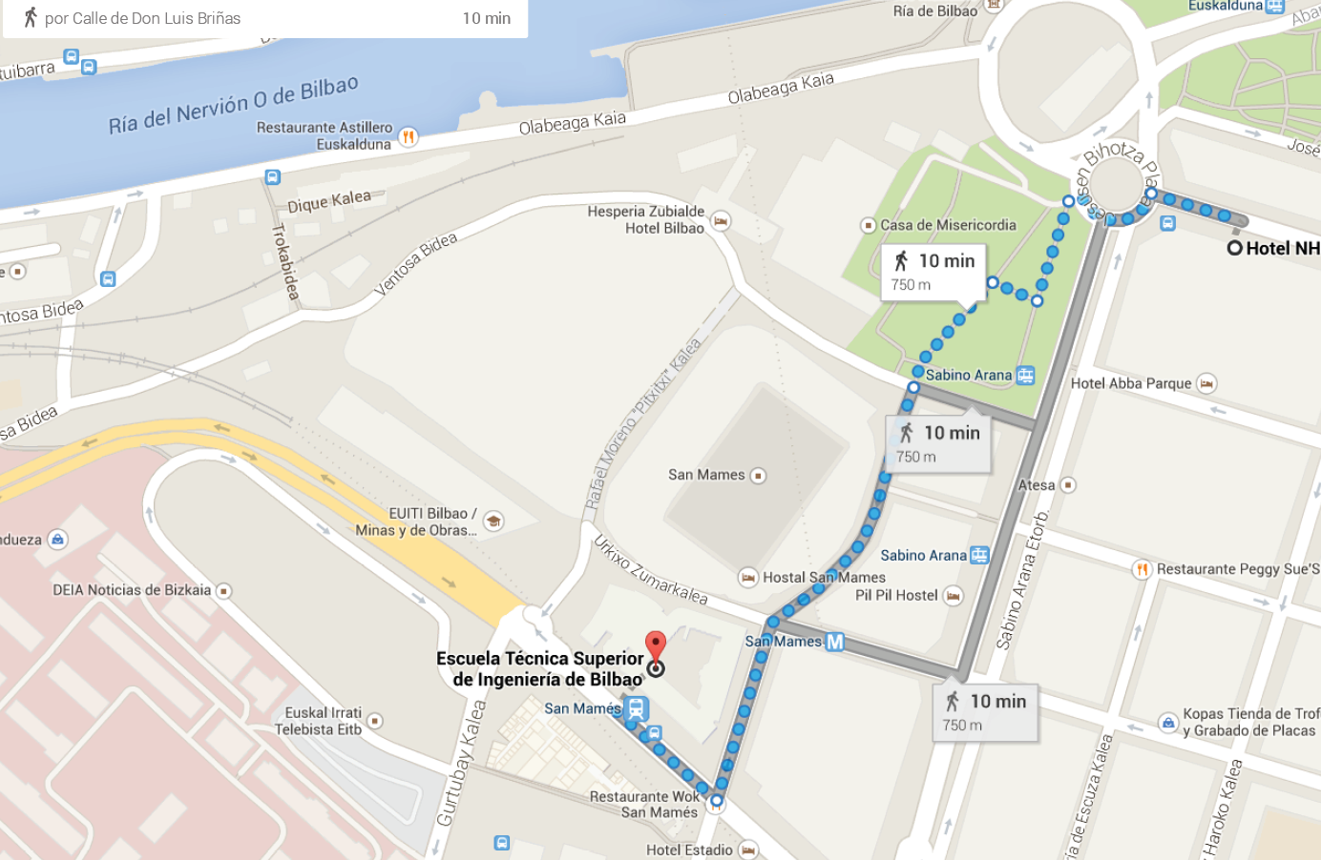
Figure 7: Location of the Faculty of Engineering and the NH Hotel

Interoperability Tests room information:
- Name: P1G1A
- Location: G building
- Recommended Entry: Luis Briñas Street (closer o the Metro elevator, see next MAP)
Figure 8: Interop. premises location

SHIPMENTS LOGISTICS

Shipment address
All the packages for the Interop in Bilbao, must be delivered to the following address:

Att: D. LUIS URIA (Laboratorio de Tecnología Electrónica)
ESCUELA TECNICA SUPERIOR DE INGENIERIA (FACULTY OF ENGINEERING UPV/EHU)
PLAZA ING. TORRES QUEVEDO, 1
48013 BILBAO
SPAIN

Telephone: +34 644064541

Dates for packages collect/delivery

All the packages sent to this event will be stored in a specific premise in the Faculty of Engineering of Bilbao. The interop event will be help in the same Faculty.

The dates opened to collect packages are:
From July 7th to July 15th

The transport companies can collect the packages at the same address in the following dates:
From July 16th to July 23rd

(Except Saturdays and Sundays)

If anyone requires any special arrangement regarding the logistics, please contact aitzol.zuloaga@ehu.es

HOTEL INFORMATION

NH COLLECTION VILLA DE BILBAO HOTEL

This is the suggested first option.

Address: Gran Vía, 87 | 48011 Bilbao | SPAIN
Phone: +34 94 441 60 00, ge.dearrese@nh-hotels.com, www.nh-hotels.com
Hotel class: 4 stars

Prices per room and night (reservation till 2014/7/2):

In: 14/07/2014
Out: 16/07/2014

Single room: 82 euros
Double room: 93 euros
Buffet breakfast: included
Value-addeed tax (VAT) Not included: 10%
To book phone or mail (nhvilladebilbao@nh-hotels.com) and give the reference "IEC 61850 AND IEC 62439 TECHNICAL INTEROPERABILITY TEST".

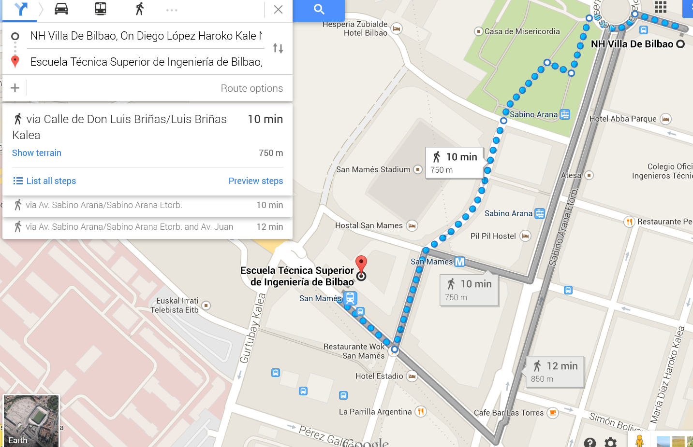
Figure 9: NH Bilbao Hotel Location

HESPERIA ZUBIALDE HOTEL

Address: Camino de la Ventosa, 34, 48013 BILBAO, SPAIN
Phone: +34 94 400 81 00, hotel@hesperia-zubialde.com, www.nh-hotels.com
Hotel class: 4 stars

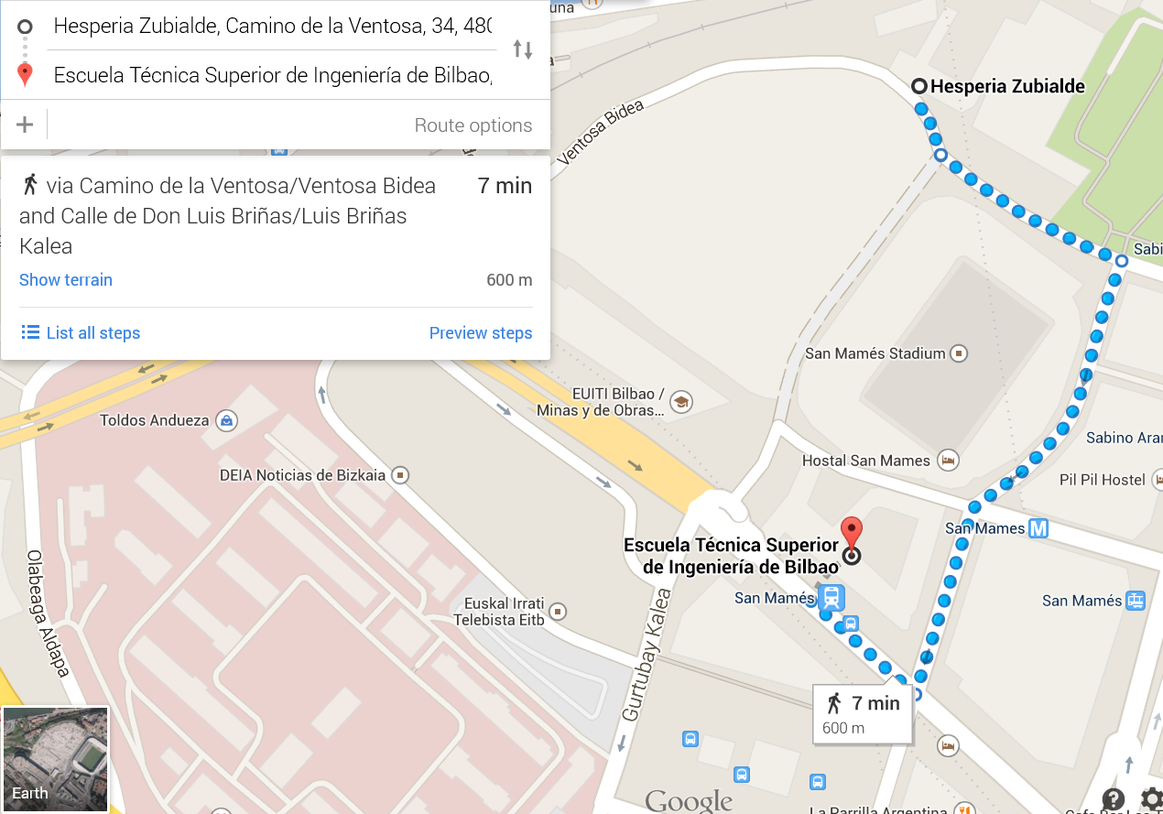
Figure 10: Hesperia Hotel Location

ERCILLA HOTEL

Address: Calle de Ercilla, 37-39, 48011 Bilbao, Vizcaya
Phone: +34 944 70 57 00, http://www.hotusa.com/hotels/spain/vizcaya-bilbao/bilbao/hotel-ercilla.html
Hotel class: 4 stars

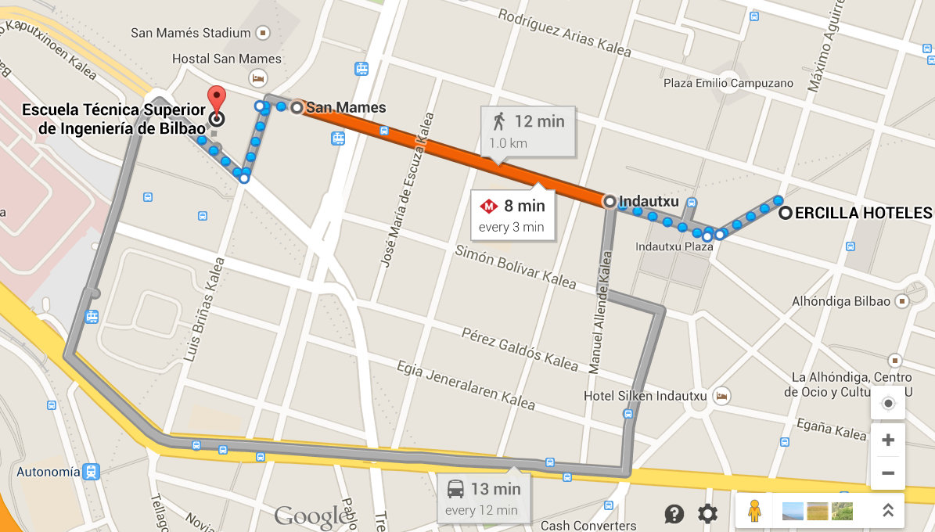
Figure 11: Ercilla Hotel Location

