Removing Cookies from IE 8

- From any tab in the IE browser, select Tools | Internet Options near the top right of the screen.

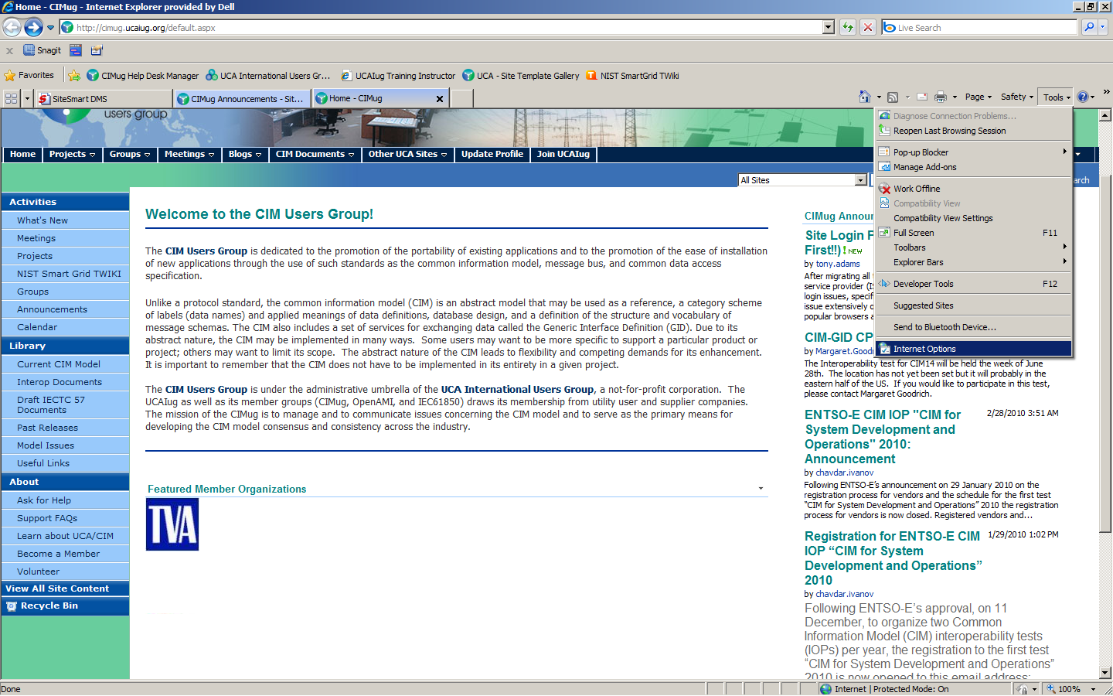

- From the popup window, select the Settings button found in the Browsing history section. Alternatively, you can select the Delete button to the left of the Settings button. You can then select to delete all your cookies if you choose.

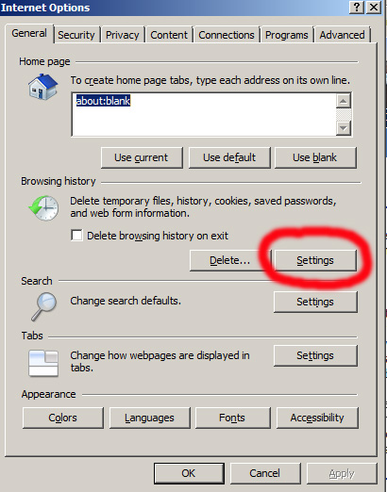

- Select the View Files button from the resulting dialog box.

- The next screen is a list of all your Internet Explorer cookies.

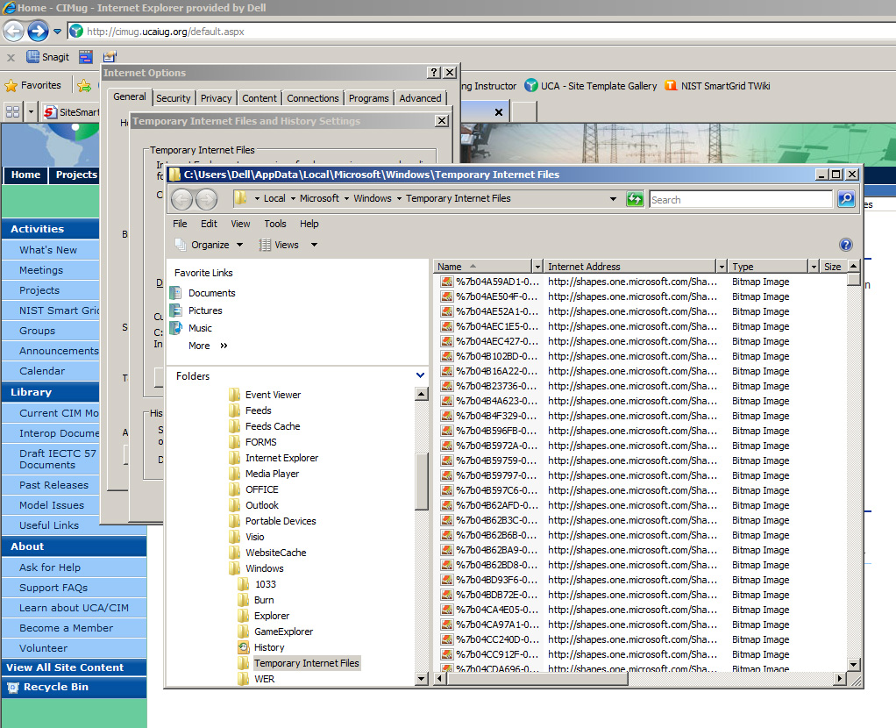

- If using Windows Vista, a search box is provided for you. If using Windows XP, you will need to select the Search button just below the cascade menu (File, Edit, View …) at the top. Enter in UCAIug and press the <ENTER> key on your keyboard.

- This will produce a listing of all the UCAIug related cookies. Delete them one at a time, or altogether.

- Exit back to the main IE browser screen and close the IE browser.

- Restart the IE browser and navigate to a UCAIug site (UCAIug.org, CIMug.org, OSGug,org, etc).

- Attempt to login by entering your account credentials. You should successfully login.

