CIMug SharePoint Improvement Suggestions

December, 2011

Introduction
The objective of this EPRI project is to make recommendations to improve the user experience of the CIMug SharePoint site. The focus is on making it easier to find and access material for several classes of users.
This white paper is a first step in collecting requirements based on different classes of users. The idea is to try to identify what the use cases are for each type of user. The next step is to evaluate how well the current site organization meets these requirements and identify the gaps where improvements are needed to improve the user experience. Next is developing recommended changes and evaluating feasibility. The final steps include implementation of the recommendations and validity checking of the changes.
The approach is for a core team to provide a draft for each step and then have a broader group to review and suggest changes where needed. The core team initially comprises Pat Brown, Terry Saxton, Alan McMorran, and Tony Adams. The broader group includes the CIM Process WG members.

User Requirements

Novice – utility manager, beginning implementer
- Menu for new CIM users – entry point about what to expect on this site
  - Creating an account
  - FAQs
  - Help desk
  - Model Issues
- CIMug overview – purpose, relation to other user groups (e.g., OpenSG, 61850, etc.)
- CIM overview – what CIM is, how it’s used, its purpose, what its benefits are, domains of application, etc. This could be a “CIM starter kit” with basic information, papers, sample model, etc.
- How standard is defined/maintained (by IEC TC57 Working Groups)
- High level IOP results
- Success/project case stories
- CIMug meeting information – past & future
- Vendor products implementing CIM (maybe a list of offerings as reported by each vendor), categorized by product space
- Parts of the standard & how complete each part is
- “CIM for Dummies” link
- View into CIM based on subject area which would also provide some idea of maturity of this part of CIM standards
  - Assets
  - Outage
  - Consumption
  - Maintenance and construction
  - Customer support
  - Meter reading and control
  - Wires/network models
  - Network extension planning
- High level view of reference architecture

Experienced Implementer - Utility architect, system integrator, vendor programmer
- Latest version of UML model and previous versions, clearly labeled
- Drafts of all sections of all 3 standards, with indication of state of completion, organized logically (by standard, but also by purpose (61970-301 and 61968-13 “do” the same thing, etc.). Also need an explanation of what a draft standard is.
- Detail of profiles (for exchange of network model (operations, planning, dynamic), for AMI messages, for Work Order messages, for Asset messages, etc…)
- Explanation of use of model, profiles, rdf, XML Schema, OWL, xsds etc.
- Detailed view of reference architecture
- WG13/14/16/19 responsibilities and something that makes it clear what the current areas of work are (minutes from meetings?, summary of work in progress? NWIPs?)
- Process for modifying standard or submitting CIM issues
- Detailed IOP results
- Available tools with functionality and procurement information
- Implementation examples (test data, profiles, message details, etc.)
- Information on upcoming IOPs
- CIMug meeting information – past & future
- Upcoming WG meeting schedule

Regulatory bodies, other standards organizations, NIST SGIP, etc.
- Menu for regulators and government officials
- CIM overview – what it is, how it’s used, its purpose, what its benefits are, maturity (including status of certification/IOP testing)
- Level of adoption of standards by utilities, TOs, RTOs, ISOs, internationally
- Relationship to other standards
- Role in NIST SG framework/roadmap
  - How used to achieve SG interoperability
  - Point out where CIM appears in lists of recommended standards
  - Which PAPs use the CIM standards
- How to purchase CIM standards

Home Page
- Welcome to CIM Users Group! banner
  - Remove or update 2nd paragraph (out of date text and would like banner shorter)
  - Update list of member groups in 3rd paragraph to be current & correct
- Announcements
  - Move Announcements section under Welcome to CIM Users Group! banner (so the most important Announcement is visible even before a person logs in)
  - Remove unneeded/duplicate messages
Announcements Page
- Organize list based on when posted

Left Quick Launch Proposal
[with just a few exceptions (which are noted), the left pane remains constant across all pages]
CIMug
- Announcements [no change]
- What’s New [delete… is just list of new postings and has limited value.. move somewhere else if need to keep]
- Forum (online discussion) [NEW page/function.. “Basecamp” (http://basecamphq.com/?source=notice but the link is not currently working) was suggested as a technology]
- Organization [NEW page covering purpose, governance structure, co-chairs – leverage subset of info/lists that UCAug already has?, include information from brochure currently linked to Learn About UCA/CIM, ]
- Groups (those related to CIMug could go on Organization page, other ongoing groups could appear on their own Groups page)
- Projects [see Projects note below] [could list of current projects appear if you hover?]
- Calendar [no change, though this seems never to be used….]
- Become a Member
- Volunteer
Common Information Model
- Overview [NEW page with text, excerpt from CIM Primer?]
- History [NEW page with text, excerpt from CIM Primer?]
- CIM Model [see CIM Model note below] [hover to get menu showing Current, Proposed, History links]
- CIM Interface Map [NEW see CIM Interface Map below]
CIM as an IEC Standard
- Working Groups and Draft Standards [like existing Draft IECTC 57 Documents page, but… see Standards note below]
- CIM Standards Map [NEW see CIM Standards Map below]
- CIM and other IEC Standards (NEW see Reference Architecture below]
- IEC Processes [NEW text overview of IEC standard approval process, including opportunities for input, role of CImug, etc.]
- Submit a Model Issue [like Model Issues page, no change]
CIM Testing
- Link to CIM Test Site [see Test Site note below]

CIM in Action
- Vendor products [NEW database driven with vendors providing current product information]
- Success stories [NEW page with links to utility stories, could ask utilities/vendors to write and add one every quarter]
- Implementing CIM (approaches, use of consultants, RFP language, guidance from IOPs) [NEW – good information comes out of the “Ask the Experts” session at each CIMug… ]
CIM Resources
- CIM Primer [like existing link to EPRI download page, no change]
- Tools [NEW see Tools note below]
- Papers/Presentations [NEW page with links to papers or presentations], organized by topic. Items from the CIM Model Exchange and Naming page would go here, also CIMug meeting presentations
- Useful Links [like existing, no change]

Meetings
- Upcoming [should be like existing, but existing at the moment is going to the CIMug home page…]
- Past [like Meetings page] [see Meetings note below]
About CIMug Website
- Site Tour for Newbies [NEW…]
- Ask for Help [use existing, no change]
- Support FAQs [OK]
- Sharepoint Training [link to UCAIug SharePoint Training page]

Projects [with custom left quick launch bar, much like existing] (DB candidate)
Main page should list active project info with clickable links to each project (like existing Projects Info page)
Existing CIM Projects page (with benefits and how to get started) should appear as a link on left quick launch bar, not as Projects home page
Add an Archive link to the left quick launch bar and also to Projects pulldown on Home Page
Seems like the perfect set of info to reside in a database with the following attributes for each project:
- name
- description
- project lead/manager
- project start date
- project completion date (filled in after it’s done)
- status on website (active, archived)
- membership open to…
- project site link
Need to archive CIM for Planning, CIM for UTCE (ask Chavdar – archive or toss)
Need to add CIM for Generation

Test Site
Main CIMug Testing overview page:
- CIM test categories
- CIM Testing Committee and relationship to UCAI testing organization
- Links to current testing initiatives – mostly current sites, will have restricted access
- Link to Past test reports [see Past test results note below]
- Testing tools [maybe… with links to SGCC and EPRI test tools]

Past test results (DB candidate)
Completed IOP test results could link to UCA area, but needs to clearly list all completed CIM IOPs (1 folder per test with logical name (date & name/scope) with the most current on top on one page. The text on the top of the CIM Interop Documents page describing recent & upcoming IOPs is nice. Good background. Currently there are 2 left navigation pane IOP links: “Interop Documents” and “IOP Reports”. Need to only have one.

Perhaps IOPs are a good database candidate also:
- name/scope
- description
- date
- location
- standards tested
- interfaces tested (exactly the list used to drive the CIM Interfaces Map)
- participants

CIM Model
I think it would be helpful to classify the UML model links into Current, History, Proposed. Current would be most prominent, would be on the top of the page and would be whatever version the CIM Model Managers consider the “current version”. Then Historic models could be listed grouped (in an obvious, clear manner) by version number. Then Proposed models that are under development.
CIM Interface Map
Hovering over or clicking on any colored interface line would cause a context box to appear, with links to information in a number of categories (Profiles, Serialization, Packages, IOPs, etc.)

Standards
Clarity of the IEC TC57 WG Draft Documents page is good. Would be nice if all groups titled their folders using the same format. Would be good to show status of each standard on this page

I’m not sure I understand what, exactly, is meant by:
Because UCA has a Category D Liaison relationship with IEC, draft documents for TC57 Working Groups 10, 13, and 14 can be made available to UCA members.
Does it mean the most current documents being worked on / reviewed by a WG which are at certain stages (NWIP, CD, MCR) are available for view, but that once a document becomes an IS it is not available for view? When that happens, what can be viewed? Nothing? Or the most current draft document before the one that became a standard? In this case, what constitutes the version before?

It would be good to have a database of standards with the following attributes:
- main number (61968)
- part number (9)
- status (FDIS, IS, CD, Technical Report, Working Draft, NWIP, whatever)
- version
- WG lead
- layer (model, profile, data exchange/serialization, architecture, reference & harmonization)
- interface (Network Model, Network Solution, Dynamics, Network Operations, Record & Asset Mgmt, Meter Reading & Control, Graphics)
- etc. (date status achieved?, caveats of usage (like: planned to be replaced by… or under discussion for retirement…)?, )
This could support the display/navigation envisioned for the CIM Interfaces Map and CIM Standards Map pages

CIM Standards Map
All underlined text is linked to call up / download the appropriate file. UML link should always be to whatever the CIM Model Managers consider the “current version”. Now (12/16/2011), I would think it would be the latest version of CIM 15. Each standard should have its name, number & status displayed.

Reference Architecture
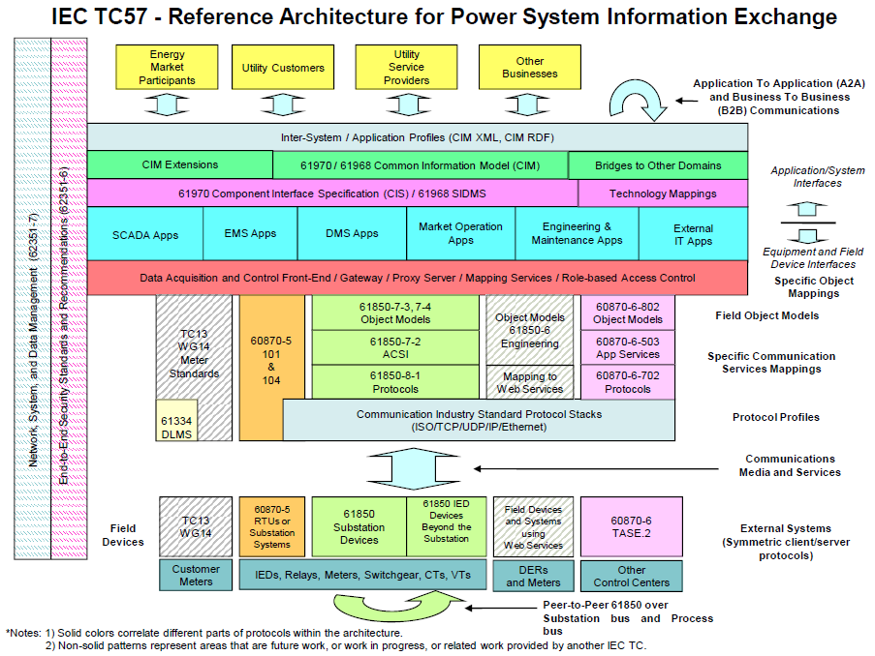

Tools
Page (like CIM Tools for CIM Power System Models slide below) with graphical layout of tools. Hovering or clicking would get a context window popup containing the information shown in the 2nd slide. Database-driven, might even be part of the Vendor Products database, with an additional attribute signifying that it’s a CIM tool product.

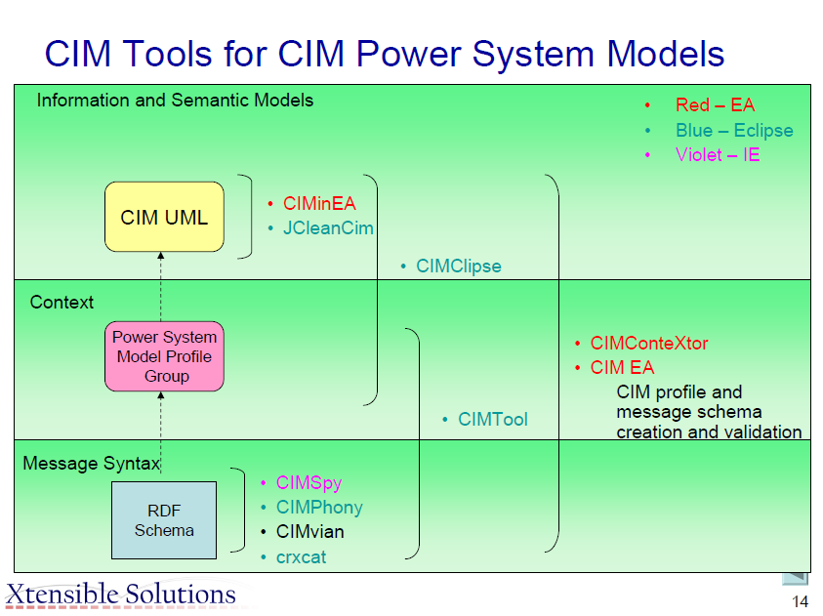

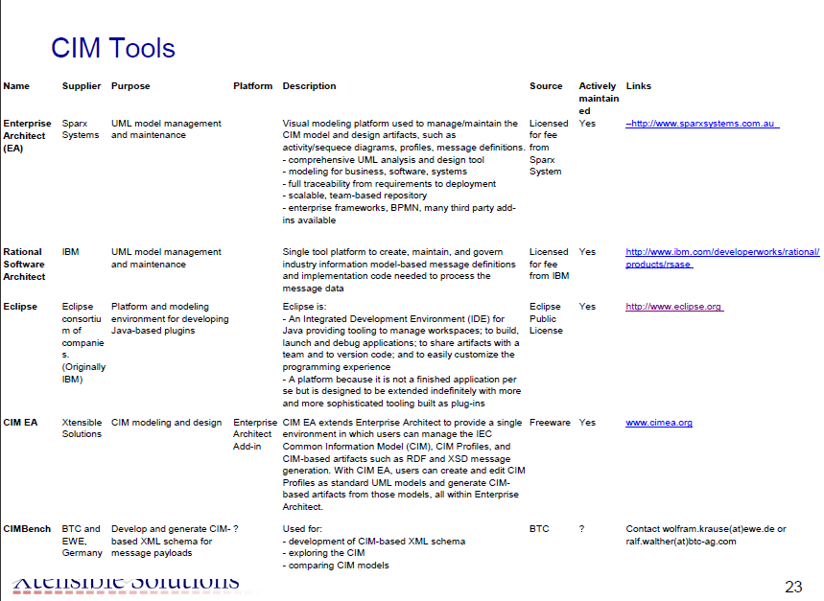

Meetings [different left pane, listing meetings]
Existing organization is pretty good, we should be consistent in the left pane organization & entries from one meeting page to the next meeting page. Meeting Documents page organization is fine with a folder for each day, but presentations inside folders need to be in Agenda order and the presentation title (as shown on the Agenda) and the person who actually spoke need to be shown. Does this need to be database driven?

Improvement Process
To contribute to the work of improving the CIMug website, contact
Terry Saxton tsaxton@xtensible.net
Pat Brown pbrown@epri.com

The feasibility of suggested improvement strategies will be explored with UCAI personnel responsible for CIMug website maintenance and the results will be submitted to the CIM Process Working Group for approval.

Suggestions Received
- Set up a forum for anyone to post and converse with others on CIM topics.
- Could we add discussion forums to quick launch bar which would like to the current forums. DTE mentioned they would like to find something on the front page that would let a person quickly get involved in a community forum on a subject of interest. - Terry
  - Create a page that has nothing but a CIMug forum displayed (using the GEF webpart). We could announce its creation, seed it with a few pertinent threads and let people have at it. From there, folks could email/call each other privately with their contact information if they would like to, thus alleviating us from the legal ramifications of releasing these details. No, the GEF webpart does not have a private messaging feature like typical forum software, so people are going to have to post their contact details out there in a thread that subscribers can view. However, it is them making that decision and not us, and they can choose how little or how much and in what format they want to divulge their contact details. - Tony
- On CIM interface map, note under data exchange and serialization the GID standards have been rescinded. If this section is to deal with syntax and serialization (i.e., 5xx standards), you could list Part 501, 552, and future 502. You could list the OPC UA standard IEC 62542. Under Architecture, could add IEC 62357 Reference Architecture for Power System Information Exchange. - Terry
- Show Editions as well a status on IEC documents.- G. Gray
- Use of Basecamp for tracking message threads of requests for help (?) – Nigel
- Menu for new CIM users – entry point about what to expect on this site - Terry
  - Creating an account
    - For first timers, need to change title to “Please register as a new user to access more information”.
    - Also, need to have required fields indicated with an “*”
    - Confirmation of successful registration should also include username (because username is assigned by Sharepoint, it is not one you pick yourself. You should not have to go to email to find it.)
  - FAQs
    - need updating and reordering and separation
      - CIM FAQs
      - CIMug and Site FAQs
    - Need to relocate the new FAQs from Help desk to here.
    - Guests should not be able to create a new FAQ (they can now)
  - Help desk
    - Need to take advantage of announcements section for Tony, others, like new projects set up, etc.
    - Need to split into Site and CIMug help and CIM help
  - Model Issues
    - Change to say ‘Submit CIM Model Issues”. Then on that site, state guests can view, members can submit.

Irritants we still have (4/27/12)
Pull downs are slow to populate
CIMug announcements web page should sort by posting, not expiration date (current announcements are at bottom because they have not expiration date)

Dan Jablonsky. Subversion plus need for database.
AI – Check to see if Dan is up on document repositories.

